Forty Years of Pediatric Intensive Care at Hacettepe
Founded in 1985 as the first pediatric intensive care unit (PICU) in Türkiye, the center has evolved into a comprehensive academic and clinical hub that has played a pioneering role in the institutionalization of pediatric critical care nationwide and has become a landmark institution in the field.
The establishment and progressive development of the Pediatric Intensive Care Unit (PICU) at Hacettepe University represents far more than the history of a single clinical entity. Rather, it embodies the emergence, maturation, and institutionalization of pediatric critical care medicine in Türkiye, reflecting a trajectory aligned with international standards of care, education, and research.
From its inception, the unit adopted a closed-model organizational structure, standardized admission criteria, and dedicated multidisciplinary staffing principles now widely recognized as essential for high-quality intensive care delivery (1-3).
Over time, the unit expanded its infrastructure and integrated advanced life-support technologies, including mechanical ventilation, continuous renal replacement therapies, and extracorporeal membrane oxygenation (ECMO). The introduction of ECMO marked a major milestone in the advancement of pediatric critical care capabilities in Türkiye.
In parallel, the development of formal subspecialty training programs and translational research initiatives strengthened its academic mission. The institution of the dedicated Life Support Center further enabled innovation in simulation-based education and clinical research with international collaborations.
Today, the unit has emerged as a leading quaternary referral center, integrating clinical excellence with education and research. This trajectory exemplifies how visionary leadership and institutional commitment can shape sustainable pediatric critical care systems.

1. The Foundational Period: 1985
The origins of pediatric intensive care at Hacettepe date back to 1985, when the first PICU in the country was established within Hacettepe Children’s Hospital. The unit was inaugurated by the then Chief Physician of the Children’s Hospital, Prof. Dr. Namık Çevik (Fig. 1). Initially designed with a capacity of six beds, the unit began operation equipped with a centralized oxygen system, pendants, monitors, and mechanical ventilators (Fig. 2). Architecturally, the unit featured an integrated structure centered around a central nursing station, with bed formations and logistical areas including storage rooms, nurses’ rooms, restrooms, and physicians’ offices. From its inception, the unit adopted a closed-model organizational structure, with dedicated personnel and clearly delineated clinical protocols an approach that would later become a hallmark of modern intensive care systems.
The early clinical practices implemented in this period including selective admission policies, avoidance of terminal-stage admissions, and structured patient flow back to general wards demonstrate a remarkably forward-thinking alignment with present-day critical care ethics and resource stewardship. Staff organization was designed in accordance with modern intensive care standards. Under the supervision of the head nurse, care was provided with a nurse-to-patient ratio of 1:2. Over the years, the responsibility of head nursing was passed on successively. The nurses who devotedly fulfilled this important role from the establishment onward were, respectively: Hacer Ergin, RN (1985–1997), Gonca Alkan, RN (1997–2004), Şermin Özeski, RN (2004–2010), Arzu Bütün, RN (2010–2013), Gülten Kızılkaya, RN (2013–2015), Semra Çavuş, RN (2015–2017), Neşe Kaplan, RN (2017–present), and for the pediatric Cardiac Intensive Care Unit (pCICU), Emine Kahya, RN (2013–present). The continuous preservation and progressive strengthening of the unit’s organizational structure under the supervision of a dedicated head nurse since its establishment constitute a hallmark of the institution’s robust organizational foundation and enduring institutional continuity.
Under the operational directive prepared by Dr. Faik Sarıalioğlu, a closed-model management system was structured through the assignment of dedicated consultants and personnel exclusively for the unit. Second-year residents, a senior resident, and chief residents serving as consultants conducted the clinical operations. Dr. Erkan Karaaslan, Dr. Dilek Soysal, Dr. Funda Öztunç, and Dr. Güzide Turanlı served as the first consultant chief residents, while Dr. Oğuz Söylemezoğlu assumed the role of the first senior resident (Fig. 2). Modern ICU admission protocols such as refraining from admitting terminal-stage patients and transferring stabilized patients back to ward beds once intensive care was no longer required were also implemented during this period.
Notably, academic productivity was embedded from the outset, as evidenced by early case-based scholarly output contributing to the international literature. The first patients admitted to the unit were diagnosed with severe bronchiolitis, myocarditis, acute renal failure, and diabetic ketoacidosis (Appendix: Historical Witness Documents). Academic productivity was initiated from the very beginning, as reflected by the autopsy and subsequent publication in the scientific literature of one of the earliest patients admitted to the unit, who presented on the opening day with mumps myocarditis. (Jpn Heart J 1989;30:109–114) (Fig. 3).

2. Infrastructure and Institutional Development: 1997
In 1997, the infrastructure of the unit underwent comprehensive development and structural enhancement, including the addition of an isolation room, transforming it into a 10-bed intensive care unit (Fig. 4). This transformation was carried out under the leadership of the Chief Physician of the Children’s Hospital, Prof. Dr. Murat Tuncer, and represented a major milestone in the institutional development of the unit and laid the groundwork for subsequent academic and technological advancements.

3. Academic Vision and International Collaborations: 2001–2007
With the advent of the new millennium, Hacettepe Pediatric Intensive Care adopted the vision of becoming a national academic center beyond its role as a clinical service unit. In 2001, Dr. Benan Bayrakci was assigned to Johns Hopkins University—one of the world’s leading centers—with the mission of bringing contemporary knowledge and expertise in pediatric intensive care to Hacettepe University. This strategic initiative was strongly supported by the Chair of the Department of Pediatrics, Prof. Dr. Gülsev Kale, and became a defining milestone in the academic development of pediatric intensive care medicine in Türkiye. The training of key faculty at leading global centers—most notably Johns Hopkins University—facilitated the transfer of advanced knowledge and clinical expertise into the national context.
Upon Dr. Bayrakci’s return in 2002 and assumption of PICU leadership, the unit gained invasive and centralized monitoring capabilities, while mechanical ventilation practices became an integral and reliable component of critical care management. This period saw the integration of invasive monitoring, advanced mechanical ventilation strategies, continuous renal replacement therapies, and structured life-support training programs. Major subsequent developments included:
- 2003: Initiation of the home mechanical ventilation program
- 2004: Introduction of continuous venovenous hemodiafiltration (CVVHDF) applications
- 2006: Structuring of the Pediatric Advanced Life Support (PALS) training program, with regular monthly courses educating thousands of physicians and nurses since then
- 2007: Establishment of Türkiye’s first Extracorporeal Membrane Oxygenation (ECMO) program. The ECMO center was structured by Dr. Benan Bayrakci following his training at Johns Hopkins University, while the necessary institutional infrastructure was supported by the then Director of the Children’s Hospital, Prof. Dr. Tezer Kutluk. This initiative marked a turning point in the integration of extracorporeal life support technologies into clinical practice in Türkiye. Today, the ECMO patient cohort approaches 400 patients, with more than 600 ECMO days provided annually.
The establishment of the first Extracorporeal Membrane Oxygenation (ECMO) program in Türkiye in 2007 constitutes a landmark achievement, signifying the unit’s transition into a high-complexity tertiary referral center.

4. Academic Institutionalization and Subspecialty Training: 2009–2015
Recognition of pediatric intensive care as an academic discipline in Türkiye was achieved in 2009 through the TUKMOS studies conducted with the contributions of Dr. Bayrakcı, leading to its acceptance as a pediatric subspecialty field. Subsequently, in 2010, the Hacettepe University Division of Pediatric Intensive Care was formally established, and Associate Professor Dr. Benan Bayrakcı was appointed as the founding division chief. Thus, Türkiye’s first Pediatric Intensive Care Subspecialty Training Program was initiated. This initiation not only ensured the sustainability of expertise but also catalyzed the dissemination of pediatric critical care knowledge nationwide.
Dr. Selman Kesici became the first graduate of Pediatric Intensive Care training programs in Türkiye, successfully completing his fellowship in 2014. He returned to the same program as a faculty member in 2018 and has since played an active role in training future specialists. His contributions have further reinforced the unit’s clinical excellence and academic legacy. Over the following years, numerous specialists trained within the program contributed to pediatric intensive care medicine through academic and clinical positions both nationally and internationally.
The first Joint Pediatric Intensive Care Training Program in Türkiye was conducted between 2013 and 2019 in collaboration with Ankara Children’s Hematology Oncology Training and Research Hospital, further strengthening the nationwide impact of the “Hacettepe tradition.”
Additionally, in 2018, the Certified Pediatric Intensive Care Nursing Training Program was established in collaboration with the Turkish Ministry of Health, representing another major national contribution to intensive care science.

5. Modernization and Academic Expansion: 2011–2024
In 2011, the “PAYlaşım” meetings were initiated to facilitate broader dissemination of knowledge and experience, and these meetings have continued annually with increasing participation.
Continuous modernization efforts culminated in the relocation of the unit in 2013 to a technologically advanced infrastructure, 16-bed facility, accompanied by measurable improvements in clinical outcomes, including a sustained reduction in standardized mortality ratios, during Dr. Benan Bayrakci’s tenure as Chief Physician of the Children’s Hospital. Standardized Mortality Ratio (SMR), considered one of the most important quality indicators in intensive care declined to as low as 0.28 and has remained consistently at this level.
Beginning in 2018, the Pediatric Intensive Care academic staff also assumed responsibility for the management of an 8-bed pediatric cardiac intensive care unit (pCICU). The subsequent expansion to include pediatric cardiac intensive care further reinforced the unit’s comprehensive critical care capacity.
With the establishment of the modern infrastructure in 2013, new opportunities emerged for ECMO implementation, and the ECMO program gained substantial momentum through the dedicated efforts of Dr. Selman Kesici and Dr. Murat Tanyıldız.
In parallel with clinical and educational advancements, the unit demonstrated a strong commitment to innovation and scientific production. In 2015, the Life Support Application and Research Center (LSC) was established to further advance scientific production and educational activities. This center became a major academic platform for research, simulation-based education, and the development of novel therapeutic approaches (lsc.hacettepe.edu.tr).
Thanks to its infrastructure and highly qualified academic personnel, several innovative methods were introduced into the scientific literature. These contributions include:
- The “Zipper Method of Hacettepe” as a novel immunomodulation technique (4, 5)
- The “PISA” treatment protocol for severe COVID-19-associated MIS-C (6)
- The “SeLBA” method for the recruitment of left lung atelectasis (7)
- The “Rapid Sequence Apheresis” technique for poisoning treatment (8)
- ECMO-supported mesenchymal stem cell therapy for hypoplastic lung disease (9)
- Hyperbaric oxygen preservation of donor organs prior to transplantation (10,11)
- The Hacettepe carbon monoxide–based apnea test procedure in ECMO patients (12)
- The use of dialysis membranes as oxygenators: the “Dialoxygenation” method (13)
In 2024, the Life Support Trust Foundation was established under the same name to promote and sustain scientific research activities, while also providing structured social support for patients and their families (yasamdestegivakfi.org).

6. Current Status
Today, the Hacettepe University Pediatric Intensive Care Division functions as a national quaternary referral center, integrating advanced clinical care, education, and research across a broad spectrum of critical illnesses, including extracorporeal life support, transplantation, intoxications, perioperative care, blood purification therapies, and trauma.
With a total capacity of 23 intensive care beds across general and cardiac units, the department continues to play a defining role in shaping the future of pediatric critical care medicine in Türkiye and beyond.
These activities are currently coordinated by Prof. Dr. Benan Bayrakcı, Associate Professor Dr. Selman Kesici, and Associate Professor Dr. Mehmet Çeleğen. Pediatric intensive care fellows, chief pediatric residents, pediatric residents, and medical interns actively participate in educational, research, and clinical activities.
Since its establishment, Hacettepe Pediatric Intensive Care has continued to evolve in line with the principles of leadership, scientific productivity, and clinical excellence, remaining one of the pioneering centers shaping the future of pediatric intensive care medicine. This sustained development was further commemorated in 2025 with the 40th anniversary congress, organized with the participation of leading international authorities, during which the idea of documenting this historical trajectory as a guiding framework for newly established intensive care units was conceived (Fig. 5).
This editorial highlights not only the historical evolution of a pioneering institution but also underscores a scalable model of how clinical necessity, academic vision, and institutional leadership can converge to establish a sustainable and internationally competitive critical care system.

References:
- Pollack MM, et al. Pediatric intensive care outcomes. Crit Care Med.
- Marshall JC, et al. Intensive care organization and outcomes. Intensive Care Med.
- Bartlett RH. ECMO: historical perspective. ASAIO J.
- Kesici S, Tanyıldız M, Yetimakman F, Bayrakci B. A novel treatment strategy for severe Guillain-Barré syndrome: zipper method. J Child Neurol. 2019;34(5):277–283. doi:10.1177/0883073819826225.
- Bayrakci B, Kesici S. The zipper method of Hacettepe: a promising method of immunomodulation. J Child Neurol. 2020. doi:10.1177/0883073819900718.
- Saritas Nakip O, Kesici S, Bayrakci B. The zipper method as an emerging treatment option for severe Guillain-Barré syndrome related to COVID-19. Autoimmun Rev. 2021;20(7):102841. doi:10.1016/j.autrev.2021.102841.
- Ozturk Z, Bayrakci B. A novel technique with double catheter suctioning for clearing left lung atelectasis: selective left bronchial aspiration (SeLBA). Clin Respir J. 2019;13(11):728–732. doi:10.1111/crj.13082.
- Kesici S, Saritas Nakip O, Korgal N, Bayrakci B. A large pediatric cohort of colchicine intoxication: prognostic factors and experience with rapid sequence apheresis. Clin Toxicol (Phila). 2026. doi:10.1080/15563650.2026.2657988. Epub ahead of print. PMID: 42089449.
- Karacanoğlu D, Çeleğen M, Yavuz S, Katlan B, Kesici S, Bayrakci B. An inspiring horizon in congenital diaphragmatic hernia with mesenchymal stem cell therapy. Chest. 2022;161(6 Suppl):A548. doi:10.1016/j.chest.2022.04.082.
- Bayrakci B. Preservation of organs from brain-dead donors with hyperbaric oxygen. Pediatr Transplant. 2008;12:506–509. doi:10.1111/j.1399-3046.2007.00858.x.
- Bayrakci B. Preservation of organs from brain-dead donors with hyperbaric oxygen. In: Esquinas AM, ed. Applied Technologies in Pulmonary Medicine. Basel, Switzerland: S. Karger AG; 2011:114–118. ISBN: 978-3-8055-9584-1.
- Nakip OS, Kesici S, Terzi K, Bayrakci B. Apnea test on extracorporeal membrane oxygenation: step forward with carbon dioxide. J Extra Corpor Technol. 2022;54(1):83–87. doi:10.1182/ject-83-87. PMID: 36380825; PMCID: PMC9639689.
- Karacanoğlu D, Bedir E, Nakip OS, Kesici S, Duran H, Bayrakci B. Dialoxygenation: a preclinical trial for transforming the artificial kidney into an oxygenator. ASAIO J. 2025. doi:10.1097/MAT.0000000000002260. PMID: 39008795.

Fig. 1: Opening ceremony in 1985, with Professor Namık Çevik cutting the ceremonial ribbon.

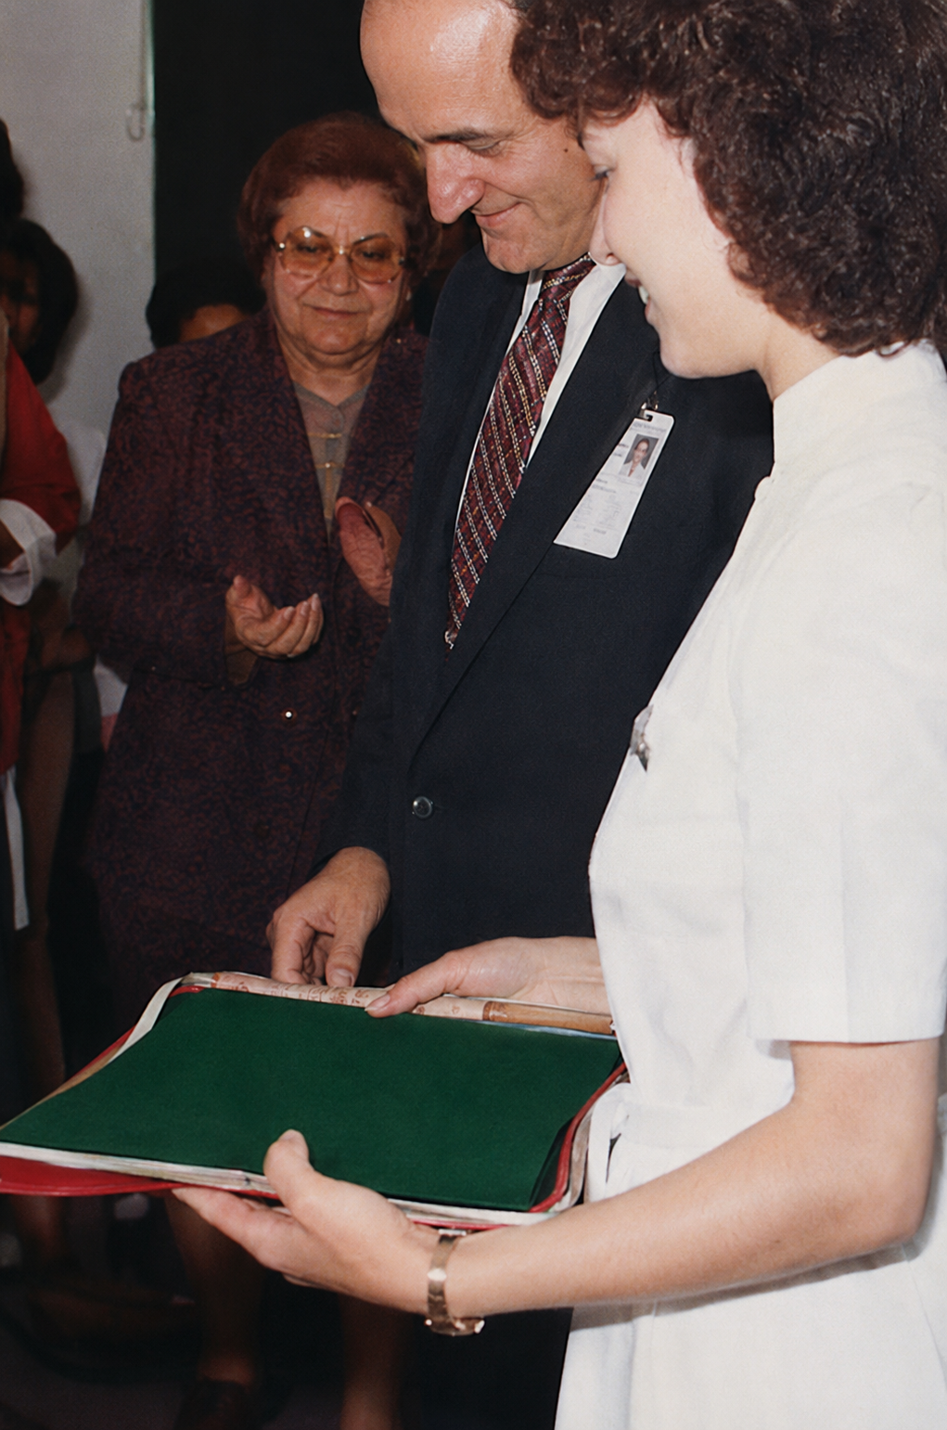

Fig. 2: An early view of the unit, highlighting bedside pendants, locally manufactured monitors, Bird-type mechanical ventilators, and a dedicated intensive care team
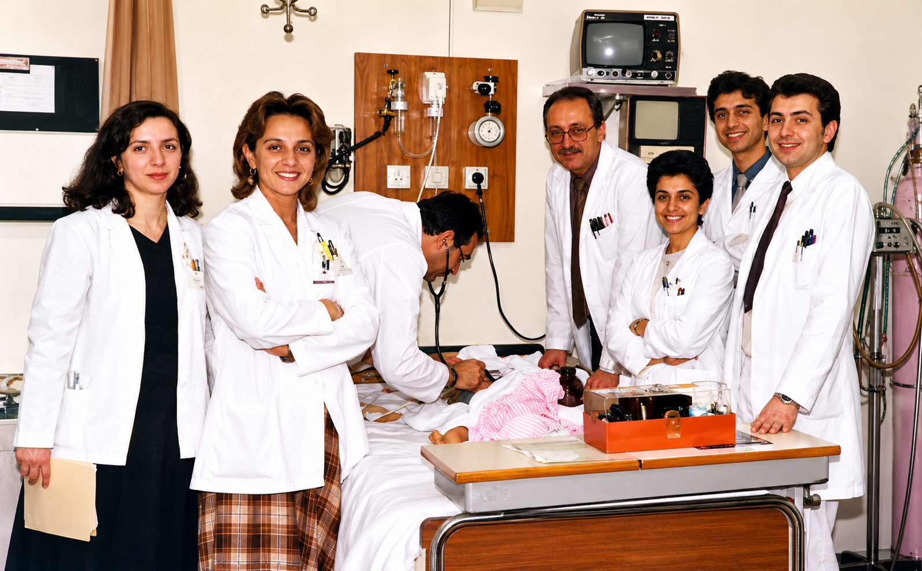
Fig. 3: First academic manuscript was produced representing one of the earliest patients admitted to the PICU—illustrating that scholarly output began from the very first day of clinical activity following the unit’s opening
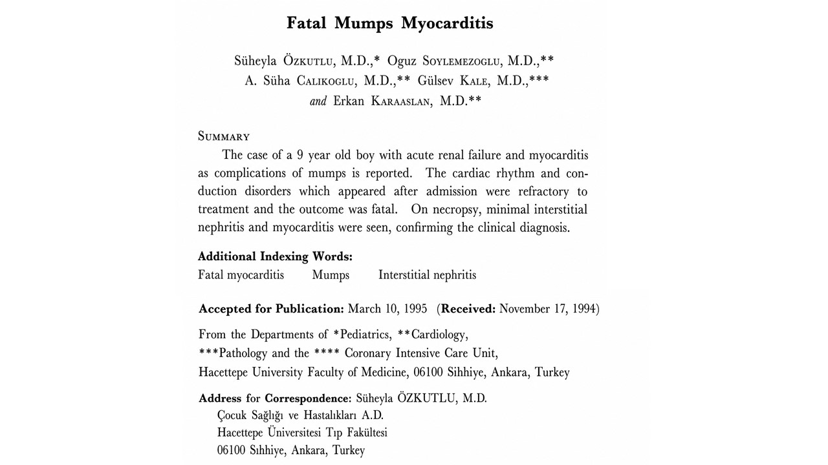
Fig. 4: The floor plan of the 1997 renovation, reflecting the layout during the improvement phase, demonstrates architectural characteristics similar to the intensive care unit design of El Camino Hospital (California), constructed in 1960
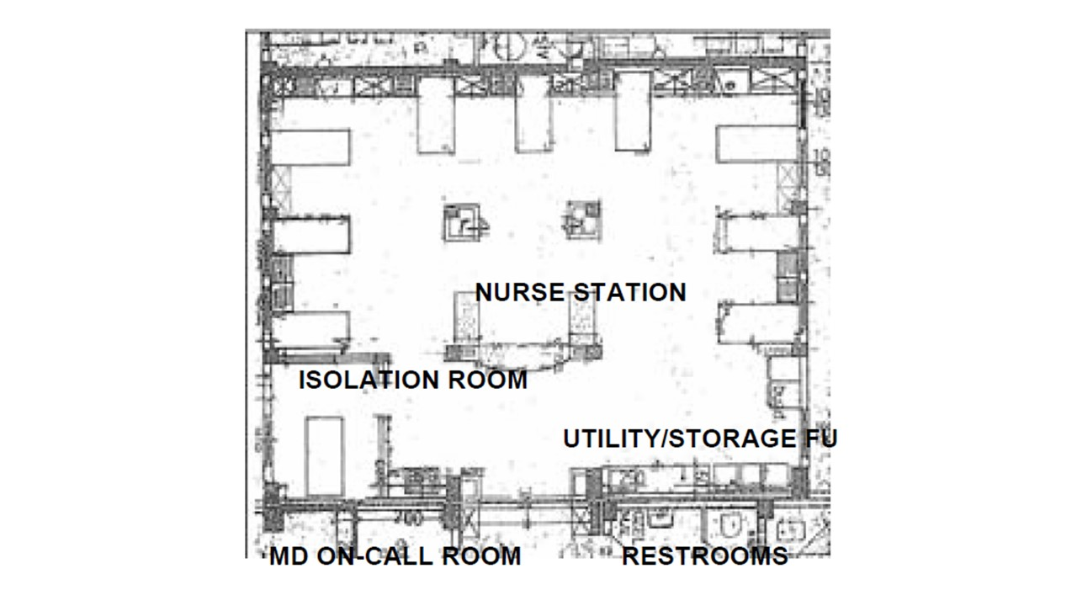

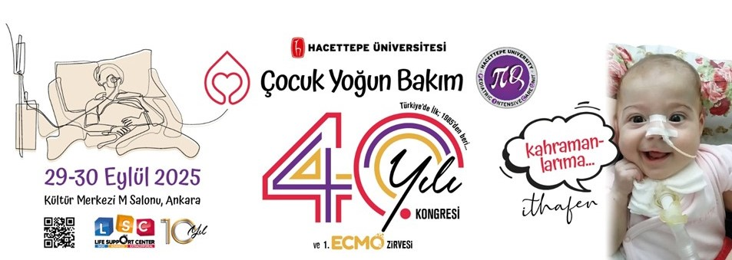
Fig. 5: Poster of the 40th Anniversary Congress held in 2025

Appendix: Supplementary Material
Historical Testimonies on the Establishment of Pediatric Intensive Care at Hacettepe University
This supplementary file contains translated and edited firsthand accounts from clinicians involved in the early establishment of the unit. Testimonials were collected in response to a request circulated through the Hacettepe Pediatrics alumni network for documents and historical materials related to the unit’s establishment in preparation for a presentation at the 40th anniversary congress. The material represents a synthesized account of the responses received.
Prof. Dr. Faik Sarıalioğlu describes the clinical necessity that led to the creation of a dedicated intensive care unit, particularly in response to critically ill oncology patients with tumor lysis syndrome and limited treatment options.
Early conditions were marked by insufficient monitoring and respiratory support systems, requiring improvised solutions such as manual ventilation and custom dialysis techniques.
Dr. Ali Süha Çalıkoğlu provides insights into the first operational period, highlighting the challenges, excitement, and clinical learning experiences. He recounts one of the first published cases, demonstrating early academic engagement.
Additional contributors describe the introduction of monitoring technologies, interdisciplinary collaboration, and demanding working conditions, reflecting both the limitations and strengths of the early system.
Collectively, these testimonies provide a unique qualitative perspective on the origins of pediatric intensive care in Türkiye, complementing the main editorial by illustrating the human, clinical, and institutional dimensions of this pioneering effort.

Historical Witness Documents
Narrator: Dr. Faik Sarıalioğlu
02 September 2025 – Of / Trabzon
A message posted by Dr. Benan Bayrakci in the Hacettepe Pediatrics Alumni WhatsApp group requested documents, recollections, and photographs related to the establishment of the Intensive Care Unit, noting that the unit founded in 1985 was the first of its kind in Türkiye. I believe the following account may be of value. This narrative could further be expanded with the recollections of residents and chief residents who worked between 1985 and 1990.
I did not keep written notes from those years. What I recount here are memories from exactly forty years ago. I apologize in advance for any omissions or inaccuracies.

Working Conditions in Pediatric Oncology (1982)
On 22 September 1982, after returning from military service, I began working in the Pediatric Oncology Unit. At that time, I was the sole attending physician working with Prof. Dr. Münevver Büyükpamukçu. Dr. Canan Akyüz was serving as a fellow. The patient load was extremely high, while staffing was very limited.
Early each morning, I completed oncology ward rounds, examined nearly forty outpatients in clinic, intermittently checked hospitalized patients during emergencies, and performed lumbar punctures and bone marrow aspirations during lunch breaks with the assistance of colleagues who had previously rotated through our service and were then working in outpatient clinics. After 18:00, I revisited the wards, and on three evenings each week, after 21:00, I attempted to conduct experimental studies in Prof. Dr. Emin Kansu’s laboratory.
Münevver abla, Canan, thesis resident Dr. Taha Çelikkanat, and I were working under demanding yet highly productive conditions.

Tumor Lysis Syndrome and Clinical Challenges
One of our most urgent problems in oncology during those years was tumor lysis syndrome (TLS), particularly in patients with Burkitt lymphoma.
Prof. Dr. Namık Çevik was simultaneously serving as Chief Physician and Director of the Institute of Child Health. One Saturday, I encountered him in the hospital. He asked about the patients on the ward, and together we visited a patient with Burkitt lymphoma whom we had been forced to place in the physicians’ room on the left side of the corridor in Ward 22.
The patient had been referred overnight from the SSK Hospital. Diagnosis had been established through examination of ascitic fluid, but treatment had not yet begun.
Prof. Çevik remarked, “Faik, these patients arrive, low-dose chemotherapy is started, yet most are lost within the first 24 hours.”
At that time, TLS prophylaxis and management were not well understood. Even patients presenting with mild TLS rapidly progressed after receiving low-dose cyclophosphamide. Serum potassium levels rose precipitously, often culminating in cardiac arrest.
Hemodialysis was not available to us. Performing peritoneal dialysis in patients with massive abdominal tumor burden and severe ascites was extremely difficult.
Between 1982 and 1985, together with the late Prof. Dr. Nesrin Beşbaş, we improvised dialysis catheters by creating side holes in Nelaton catheters inserted between tumor masses, and performed dialysis using solutions we prepared ourselves from 5% dextrose and albumin.

Recognition of the Need for Intensive Care
I repeatedly told Prof. Çevik that following such patients on general pediatric wards was extremely difficult and that even a small dedicated intensive care unit was urgently needed.
Between 1976 and 1985, apart from the Premature Infant Unit, the hospital possessed only a few monitors and one or two ventilators. In cases of respiratory arrest, ventilation was maintained manually with Ambu bags for hours. Residents were assigned one- to two-hour Ambu ventilation shifts overnight.

Initial Academic Discussions
Prof. Çevik responded, “Let us think about it.” Within the following week, a meeting was convened with the heads of the pediatric divisions. I also attended this meeting.
The idea was entirely new. There appeared to be no strong support for the proposal.
Arguments were raised such as: “Pediatrics is inherently a discipline of acutely ill hospitalized patients, especially at night. Infectious diseases, cardiac emergencies, intoxications, hepatic coma—all are managed within their respective wards. A small separate unit could not function effectively for all these patients.”
The meeting ultimately remained at the level of discussion, and no decision was reached.

The Decision to Establish the Unit
After working hours, Prof. Çevik called me to the chief physician’s office.
“I will establish the unit,” he said.
The selected location was on the second floor, above the Institute Directorate and adjacent to Ward 22. If I recall correctly, this section had previously been used temporarily by Pediatric Nephrology.
Prof. Çevik asked me to prepare a technical report. I visited the other intensive care units in our hospital and consulted the late Prof. Dr. Mualla Karamehmetoğlu, Chair of Anesthesiology, regarding ventilators.
The report was completed by the weekend. The unit would contain six to eight beds. Oxygen outlets would be available at every bedside. Initially, three cardiac monitors and ventilators would be purchased. Renovations were completed within two months.

Designing the Operational Model
The most critical issue was how to integrate this new unit into Hacettepe’s existing ward-based pediatric system. Discussions continued with the participation of the entire academic staff.
Unlike many division chiefs, younger faculty members returning from abroad strongly supported the concept of a dedicated intensive care unit.
Prof. Çevik requested that I draft an operational directive for the unit. I prepared a single typewritten copy and submitted it shortly thereafter.

Operational Principles of the Intensive Care Unit

Resident Structure
Two residents would work in the unit. These residents would be near the end of their first year and about to become second-year senior residents. Having already rotated through all wards, they would possess broad emergency experience and would not require direct supervision from an additional senior resident.

Consultant System
The consultants of the unit would be the chief residents.
Because the unit would admit the full spectrum of pediatric critical illness, few faculty members working exclusively within subspecialties could maintain sufficient breadth in emergency pediatrics.
Chief residents, however, were responsible for nearly every aspect of hospital operations. Most patients admitted overnight were initially evaluated and managed by chief residents, who could also regularly visit the ICU from the chief resident offices located two floors above.
I firmly maintain that Hacettepe chief residents of that era performed virtually all the duties that today would belong to pediatric intensive care and pediatric emergency medicine specialists.

Interdivisional Functioning
Having chief residents serve as ICU consultants also greatly facilitated communication among divisions. This system proved highly successful in preventing conflicts and rivalries among faculty members.

Admission Principles
In addition to patients admitted directly from the emergency department, patients deteriorating while on the wards could also be transferred to the ICU.
Patients with infectious diseases from Ward 38 and Ward 24 would not be admitted.
Terminal-stage patients would not be accepted into the ICU. The ICU would not function as a terminal care ward.
Faculty members, senior residents, and residents from referring services could continue to follow the treatment of their transferred patients if they wished.
Deaths occurring after transfer to the ICU in patients who had already remained on their original ward for more than three days would continue to be recorded as mortalities of the original service.
As far as I recall, these principles were fully implemented during the early months and years.
Personally, I held no formal authority or administrative responsibility within the ICU. I merely visited when oncology patients were hospitalized there.
I was, however, frequently invited to the monthly cake celebrations.

Narrator: Dr. Ali Süha Çalıkoğlu
Emeritus Professor of Pediatrics; Division of Pediatric Endocrinology, University of North Carolina, Chapel Hill, NC. September 2025
Editor’s Note: This text was prepared in response to a call for recollections, documents, and historical materials related to the establishment of the Pediatric Intensive Care Unit at Hacettepe University Children’s Hospital. It reflects the personal testimony of Dr. Ali Süha Çalıkoğlu, one of the first residents assigned to the unit after its opening.
While planning to write a brief account as one of the first two residents who worked in the Intensive Care Unit after its establishment, in response to Dr. Benan Bayrakçı’s request for recollections, documents, photographs, and narratives related to the founding and development of the ICU at Hacettepe Children’s Hospital, I first received the written account of Dr. Faik Sarıalioğlu—who, for us, will always remain “Faik abi.”
I must say it lifted a burden from my shoulders, because I had not known most of the details he described regarding the process leading to the opening of the unit, and my own account would have remained incomplete without them. Of course, this also placed upon me the challenge of writing after Faik abi. Accepting that risk, I will attempt to describe the portion of the ICU story that I personally witnessed. I am certain there will be omissions and inaccuracies, and I trust that others who lived through those years will correct and supplement my recollections.
For younger generations who may not know me, let me briefly introduce myself. After graduating from Ankara University Faculty of Medicine in 1982, I completed compulsory service during my first year in a village near Adıyaman and during my second year in central Adıyaman. Although those years included disappointments, deprivation, and hardship, compulsory service also brought me lifelong friendships that continue to this day. Together with one of those friends, Dr. Levent Saltık, I began pediatric residency training at Hacettepe in 1984.
After serving as a chief resident between 1987 and 1988, I worked in Pediatric Endocrinology as an instructor until 1993. I then came to the United States for what was initially planned as a three-month stay. Unfortunately—or perhaps fortunately—I have remained here for 32 years. Until my retirement in July 2024 as Division Chief and Professor at the University of North Carolina, I served as faculty in Pediatric Endocrinology. Throughout this period, I tried to maintain my connection with Türkiye and especially with Hacettepe. Although it is neither the institution from which I graduated nor the place where I spent the longest part of my career, I can still say that I fundamentally consider myself a Hacettepeli.
Now let me turn to the story of the ICU’s first month.
When we first heard that the Intensive Care Unit would be opening, we first-year residents experienced both excitement and fear. Certainly, having critically ill and complex patients transferred to a specialized unit would reduce some of the burden on the general wards. On the other hand, we ourselves would inevitably have to work there. We had no clear idea what kind of experience awaited us.
Later, we learned of the operational principles outlined in Faik abi’s account. I do not know what everyone else thought at the time, but personally I liked the system very much. Therefore, when I learned that my first ICU rotation would be together with my longtime friend Levent, I was genuinely delighted. Although we had not previously worked on the same ward, I trusted him enough to know that together we could overcome whatever difficulties might arise.
I do not know what the unit looks like today, but let me try to recall its physical structure at that time. On the second floor, beside the chief residents’ office, one entered through double frosted-glass doors. A small corridor led into the ward. On the left was a small restroom, next to it the nurses’ room. On the right was a small storage room, followed by the physicians’ room. The physicians’ room had doors opening both to the corridor and directly into the ICU. Along the left wall stood open shelves above and two cabinets below. Across from them, in front of the window, was a desk containing nothing more than a desk pad and a telephone. Along the right wall stood a three-seat sofa that could also be unfolded into a bed. All the furniture was from the Tepe Mobilya collection. In the corner stood a coat rack where we could hang our white coats. Later, a portrait of Atatürk was placed on the wall beside the desk. It was a room furnished with practicality and economy.
Entering the ICU itself from the corridor, there were four beds lined along the opposite wall—perhaps six, I no longer remember exactly. Three of the beds had ECG monitors, which at the time represented a major innovation for us. Every bed had an oxygen outlet. Two nurses worked in the unit, meaning one nurse for every two patients—an extraordinary luxury by the standards of the era. When the head nurse arrived during the daytime, the number increased to three. During night shifts there were two nurses, at least in the beginning. Later, if patient numbers were low, one nurse could be reassigned temporarily to another ward.
As Faik abi described, the ICU was supervised by chief residents. In addition, a dedicated “senior resident” position was created. This resident would spend the entirety of the third year in the ICU, thereby ensuring continuity and developing true intensive care expertise. The first chief residents responsible for the ICU were Erkan Karaaslan, Dilek Soysal, Funda Öztunç, and Güzide Turanlı. The first senior resident was Dr. Oğuz Söylemezoğlu. Since Oğuz later became a chief resident, I believe he did not remain there for the full year. He was succeeded by Dr. Zafer Ecevit, who also did not complete a full year because he too advanced to chief residency. Inevitably, this led to rumors that ICU senior residency had become a stepping stone to chief residency.
When Levent and I started, the chief residents explained what was expected of us. The part most relevant to us was the expectation that the on-call resident would remain awake throughout the night, since it was assumed there would be no time to sleep. Yet the prospect of working together in intensive care excited us so much that we hardly minded.
I believe Levent was on call the first night. Apart from a severe bronchiolitis case, no critically ill patient was admitted. Since that child stabilized after some time, Levent managed to get a few hours of rest. We also got along very well with Oğuz. We even sent Levent home a little early the next morning. Around four in the afternoon, we received news that a critically ill patient would soon arrive. I will describe this case in some detail because it illustrates the nature of the ICU experience during those early days.
(The narrative subsequently continues with the detailed case presentation, CPC process, and eventual publication of the manuscript.)
After surviving for three days in the ICU, the patient was ultimately lost due to ventricular tachycardia refractory to all treatment. The family arrived on the second day. Even during the few minutes we allowed them to see their child, they witnessed our desperate efforts and expressed profound gratitude. They consented to an autopsy.
Meanwhile, we conducted a literature review and learned that fatal mumps myocarditis was extraordinarily rare. We therefore decided, “Perhaps we should publish this case,” and sought mumps serology. At the time, such testing was available only at the National Institute of Hygiene. Levent personally delivered the samples. Two weeks later, we learned that IgM antibodies supporting acute infection were positive.
We subsequently published the case (Jpn Heart J 1989 Jan;30:109–14). Because it became my first English-language publication, it holds a special place in my personal history.
This case serves as an excellent example of both the importance and the unique characteristics of intensive care medicine.
During that first month we managed many fascinating and highly complex patients. I remember my ICU rotation as an extraordinarily valuable, exciting, intense, and educational experience.
One year later, I returned to the ICU—this time as a chief resident. There is no need for me to describe that period in detail. It gave us truly extraordinary clinical experience.
Certainly, there were shortcomings. Yet the positives always outweighed the negatives.
May you all remain well.

Narrator: Dr. Dilek Demirsoy
Hacettepe Children’s Hospital Chief Residency Years (1985–1986)
Topic: The establishment of the Intensive Care Unit and early clinical experiences
Dear Benan Bayrakci,
In response to your call for intensive care memories, photographs, and experiences, I would like to contribute to Ali Süha’s account.
First of all, dear Ali Süha, I must congratulate you on remembering and summarizing the ICU experience and the case so vividly—even if you did remember my surname incorrectly.
Joking aside, I remember the mumps myocarditis case very clearly as well. The ICU had only recently opened, and we were trying both to establish the system and to provide genuinely intensive care-level management to patients who met the criteria for such care. Those were the first months of chief residency for Erkan Karaaslan, Funda Öztunç, Güzide Turanlı, and myself (Dilek Demirsoy). We were striving to avoid mistakes and to do what was best for the patients.
This patient was admitted cyanotic, tachypneic, with severely abnormal ECG findings and an extremely poor general condition. We called Süheyla abla for echocardiography consultation. Despite the late hour, she immediately came from home, evaluated the patient with her characteristic warmth, confirmed our treatment approach, and greatly reassured us.
In fact, following this case, she provided accelerated pediatric ECG training sessions for senior residents and chief residents over the next one to two months. I would like once again to express my gratitude to dear Süheyla abla for all that she contributed to our education.
As a graduate of Ankara University Faculty of Medicine, I would also like to share two memories from my earliest days at Hacettepe that still make me smile.
On only my second day as a resident, while searching for Pediatric Nephrology, I became completely lost in the corridors of Hacettepe. The first senior resident who found me wandering and rescued me from the hallways was dear Alpay Çeliker, to whom I send my warm regards.
Similarly, during my first month of residency, while preparing sodium nitroprusside solution at 23:00 in Ward 22 for a child with malignant hypertension, dear Faik abi explained to me in a single uninterrupted conversation the history of the solution, why the bottle needed protection from light, and the pathophysiology of malignant hypertension. That teaching moment remains among my fondest memories.
Finally, as an Ankara University graduate from the class of 1981, I entered this distinguished institution carrying the roots and foundations of my earlier medical education, and I emerged as a Hacettepe-trained pediatrician enriched by every-other-night call schedules, senior residency, intensive care experience, and chief residency responsibilities. I have always taken pride in both of my universities, each of which contributed profoundly to making me the physician I became.
With my love and respect to everyone. Stay well.

Narrator: Dr. Levent Saltık
Topic: Early technical and clinical practices in the intensive care unit
A brief contribution from me.
As Ali mentioned, monitors had arrived at Hacettepe for the first time, and this was a major event for us. Previously, we would essentially “monitor” patients by placing our hands over their chest to feel the heartbeat.
The monitors were Turkish-made, by the Petaş brand. They had two different sound tones: one softer and one louder. When two patients requiring monitoring were admitted, I would set one monitor to a low volume and the other to a higher volume. In this way, from the adjacent physician’s room, I could follow both patients’ cardiac rhythms by ear and ensure patient safety accordingly.
As stated in Faik abi’s founding narrative, when necessary, we would also transfer patients from other wards to the intensive care unit and return them once their intensive care needs were resolved.

Narrator: Dr. Bilge Kayıran
Topic: Intensive care duty and clinical challenges
Intensive care memories are unforgettable. In June 1986, three children from the same family were admitted due to mushroom poisoning. They were unconscious. We were on standby. I was six months pregnant and suffering from viral pneumonia.
At around three o’clock in the morning, the urgent footsteps of Prof. Güler Kanra were heard. She stated that intravenous N-acetylcysteine was needed to save these children. Since the intravenous formulation was not available in Türkiye at the time, she was extremely frustrated and was making phone calls all over the place at that hour.
Meanwhile, she also ordered me to immediately take sick leave. She told me, “A doctor must be well; you are harming your baby,” and insisted I leave. In a shift system where each absence meant three additional days of duty for others, I had to take two days of leave with great reluctance. Unfortunately, the patients with mushroom poisoning could not be saved. I, however, delivered a healthy baby on October 6.

Narrator: Dr. Zehra Elibüyük
Topic: Clinical education and teaching culture
It has been at least 30 years since I read that text, yet I still remember the patient being admitted with a presumed diagnosis of sepsis, and how the history of organophosphate exposure was ultimately explained by contamination of laundry hung in the garden during a neighbor’s pesticide spraying of trees.
Dear Faik abi, this demonstrates both your excellence as a physician and your ability to translate it into a striking written narrative. I am grateful that I met you as a fourth-year medical student during a voluntary night shift, when you were a chief resident conducting an educational ward round in Unit 35. Throughout our residency training, you remained a guiding figure for us.

Acknowledgments
We respectfully acknowledge and express our profound gratitude to all individuals whose vision, dedication, and scholarly contributions have been instrumental in the establishment, advancement, departmental structuring, and historical documentation of the Pediatric Intensive Care Unit. We are particularly grateful to Professor Gülsev Kale, who initiated the establishment of the discipline, and to the Johns Hopkins–trained faculty whose expertise shaped its foundational structure, including Donald H. Shaffner, MD; James J. Fackler, MD; David G. Nichols, MD; Ivor D. Berkowitz, MD; and Joseph G. Dwyer, BS, RRT, alongside other esteemed contributors such as Gary Oldenburg, RRT, and Cristina Josephson, RRT. We further acknowledge the invaluable contributions of Professor Timothy E. Bunchman, MD, for his mentorship in establishing the CRRT program, and extend our appreciation to Jeffrey Burns, MD, MPH; David P. Nelson; Orkun Baloğlu, MD; Joseph Carcillo, MD; and Ayşe Akcan Arıkan, MD, FAAP, FASN for their sustained commitment to education and academic collaborations. Special recognition is also due to Professor Tezer Kutluk for his pivotal support in the development of the ECMO program, in which Dr. Murat Tanyıldız also played a contributory role. Finally, we gratefully acknowledge Dr. Selman Kesici, whose contributions have further strengthened the unit’s clinical and academic legacy.
We also extend our sincere appreciation to Professor Namık Çevik and Professor Faik Sarıalioğlu for their pivotal roles in the establishment and subsequent development of the unit. We are grateful to Dr. Levent Saltık, Dr. Bilge Kayıran, and Dr. Zehra Elibüyük for sharing their foundational experiences and testimonies.
We further acknowledge all chief residents, head nurses —ranging from the first head nurse, Hacer Ergin, to the current head nurse, Neşe Kaplan—, nurses, fellows, residents, and ancillary staff who contributed to the unit from its inception, as well as the successive presidents and members of the Turkish Society of Pediatric Emergency and Intensive Care Medicine, and the distinguished members of the PAYlaşım group, for their invaluable contributions throughout the evolution of pediatric intensive care in Türkiye.

